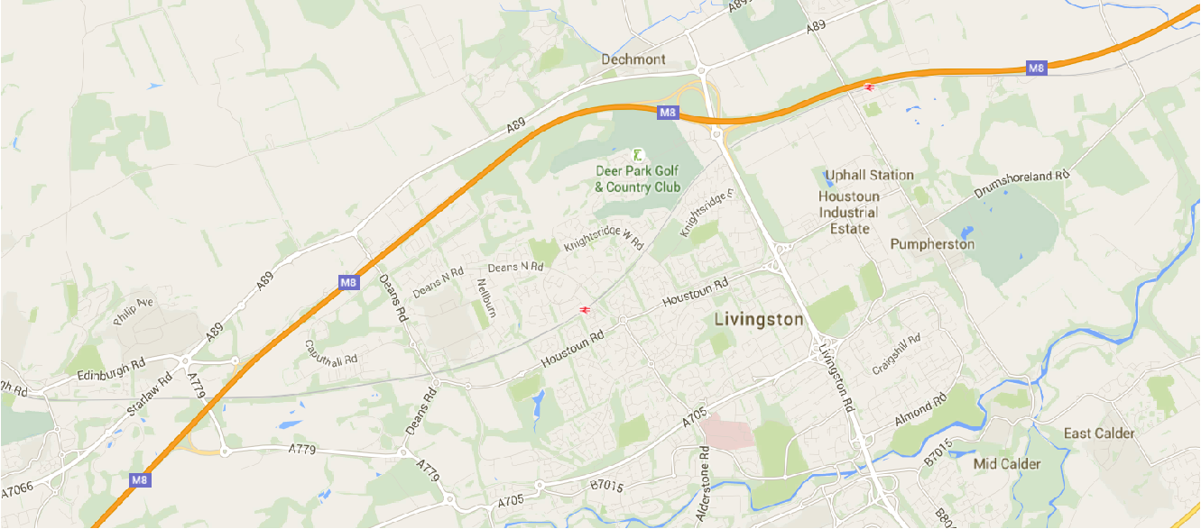

M8 Junction 3

SSOF Dechmont Law & Deans School

**SSOF Location Map, Dechmont Law & Deans Community High School, Eastwood Park, Livingston, EH54 8PS**

St. Johns Hospital